Mariusz Skonieczny

10 N. Martingale Road, Suite 400
Schaumburg, IL 60173
Tel: (847) 885-2355
mskonieczny@classicvalueinvestors.com
www.classicvalueinvestors.com

ARK RESTAURANTS
Ticker Symbol – ARKR

November 3, 2009

Business

Ark Restaurants is a New York corporation founded in 1983. Over the last two decades, the company evolved from being a holding company of small mid-priced to upscale restaurants in New York to a company with a wide range of restaurant styles with a variety of concepts. Today, it owns and/or operates 20 restaurants and bars, 30 fast food concepts, catering operations, and wholesale and retail bakeries in New York, Nevada, New Jersey, Connecticut, and Massachusetts.

Moat

A moat is what gives a company a competitive advantage which allows it to generate and maintain high returns on capital by keeping competitors at bay. Since anyone can start a restaurant, the barriers to entry into this business are low. Despite this fact, Ark Restaurants was able to create an economic moat around its business, and this is evidenced by the returns on equity below.

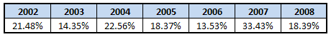

Traditionally, there are two different business models for restaurants. The first is operating a restaurant chain, such as TGI Fridays, and the second is operating an independent restaurant. Restaurant chains benefit from brand recognition, and this allows new franchisees to build clientele faster and to break even sooner in a new location. Also, the chain restaurant structure offers a cost advantage by centralizing backroom operations and taking advantage of economies of scale. The independent model, on the other hand, offers something else that a chain restaurant model does not - a unique atmosphere, which often allows the restaurant to charge higher prices than competitors in its class.

Ark Restaurants employs a unique business model which combines the best of both models. It operates each restaurant as a separate business with its own theme. By having multiple restaurants in the same city, it is able to benefit from economies of scale by centralizing backroom human resources and purchasing operations. Because it can still offer a unique atmosphere, it can price its meals above chain restaurants, but below independent restaurants of the same quality.

Another advantage of positioning multiple restaurants in the same area is the ability to vertically integrate operations. Wholesale bakeries are strategically located so that they can serve the company’s local restaurants as well as provide bakery products to other restaurants. The catering business is also located in the same area as the local restaurants.

Because each restaurant operates under a separate theme, it has to establish its own moat or competitive advantage to be a successful operation. The management achieves this by location. The company builds its restaurants in high-impact locales where customers are practically captive. The company’s CEO, Michael Weinstein described this advantage in his own words:

“If you take a Bryant Park Café or a Sequoia in Union Station or our waterfront Sequoia in Washington, I don’t care how many restaurants are built around us, we are going to have an advantage because these site-specific restaurants do good business because of the density of population.”

In the restaurant business, rent is a very significant expense which singlehandedly can make a restaurant a success or failure. Ark Restaurants has an ability to get lower rents than their competitors, and this creates a huge advantage. Many new restaurant owners focus so much on the dining part of the business that they fail to analyze if their restaurant can sustain paying rent and, as a result, many fail within a relatively short period of time. Because Ark Restaurants has been in business since 1983, possesses a pristine balance sheet, and did not ever miss a rent payment, landlords are happy to lease to Ark Restaurants at lower rates. Also, the company has a reputation of having superior negotiating skills with landlords. The management is not afraid to walk away if the numbers do not work in Ark Restaurants’ favor.

Another often overlooked advantage that Ark Restaurants has is lower employee turnover than its peers. This translates into lower training costs and, at times of extreme distress, lower payroll costs. The company’s management has done a tremendous job building loyalty among employees. For example, when one of the locations shut down for an eight-month remodeling project, the company kept the entire staff on payroll even though Wall Street was not too happy with it because of its short-term effect on earnings. The company also offers medical benefits to employees who work three shifts and allows artists and actors take time off for gigs with a guaranteed job upon their return. While treating employees in such a manner is considered unconventional, it definitely pays off in the long run. One example of this payoff happened after 9/11. As a result of Ark restaurants’ reliance on tourist locations and an overleveraged balance sheet, the company nearly went bankrupt. The employees, seeing significant drop in business, voluntarily approached Ark Restaurant’s management and offered to take a temporary pay cut. This was tremendously helpful because it allowed Ark Restaurants to cut payroll from $40 million to $30 million, which is significant considering Ark Restaurants’ size.

Finally, Ark Restaurants is one of the best payers in the industry. Usually, the company pays its suppliers within 10 days. This allows the company to enjoy bargaining power and suppliers’ loyalty.

Management

Ark Restaurants is run by Michael Weinstein, CEO and Robert Towers, COO. Both of them were with the company at its inception in 1983. It makes is less risky for shareholders if the managers have their skin in the game via stock ownership. This is certainly the case with Ark Restaurants. Weinstein and Towers hold ownership stakes of 31.26% and 1.21%, respectively.

The way the current management runs Ark Restaurants is impressive. They are in it for the long haul, and they definitely demonstrate it through their actions as mentioned in the previous sections. Investors may overlook the management’s capital allocating skills when analyzing companies. Earnings technically belong to shareholders so it is important that the management invest them in a way that creates shareholder value. Because Weinstein was an investment banker before he went into the restaurant business, he has an excellent understanding of concepts such as shareholder value and return on capital. He constantly evaluates whether it is more beneficial for the owners to pay down debt, pay dividends, buy back shares, acquire other restaurants, or open new establishments.

I particularly like the management’s decision to pay down debt since the 9/11 attack. At the end of 2000, the company was carrying $29.5 million of debt on the balance sheet which was 44 percent of assets. This amount of debt almost bankrupted the company after the 9/11 attack. Since then, the management halted expansion plans and made it a priority to improve its balance sheet. Today, the company has no debt, and this allows all of the restaurants to be cash flow positive, thus allowing the company to survive during this horrible recession.

Because the company does not have any interest payments, it is able to keep a full payroll and all the capital expenditures. Full payroll is important because, as Weinstein said, during this recession people are still expecting full service. If the restaurant does not deliver it, customers will not come back. While other restaurants might be forced to cut on payroll, this allows Ark Restaurants to steal some business away from competitors. Keeping all the capital expenditures intact keeps the restaurant properties looking in top shape and away from deterioration which can easily create a downward spiral in the business.

Another impressive decision that the management made was not giving into Wall Street’s request for share buybacks at the end of 2008. In August 2008, an analyst tried very hard to convince the management to buy back shares since Ark Restaurants had more cash than needed on the balance sheet. The CEO responded that the company was in the capital preservation mode. Can you blame him? We were in the worst economic recession since the Great Depression, and the analyst wanted the company to get rid of cash, which is the most precious asset during bad times. The management did the right thing by not buying shares back and keeping the long-term shareholders’ best interests in mind. The analyst’s employer only had its own interest in mind because it was already selling Ark Restaurants’ stock and saw other major holders all selling at the same time. They simply wanted to find a buyer to unload their own stock. So Ark Restaurants’ decision not to buy back shares was the best for the long term.

Also, during the fourth quarter of 2008, the company suspended a dividend to conserve cash. This action did not help the stock price since it was already in freefall, but again, it was the right move at that time. Now that the company recently paid a special dividend and reinstated a regular quarterly dividend, the management’s conservative approach makes me confident that the dividend is here to stay, unless, of course, something extraordinary like 9/11 happens again.

While CEOs of other companies expand their empires and look for media attention, Weinstein keeps a very low profile. He rarely does interviews with the media. He said, “I have a wonderful family and a terrific business, and I don’t want much more than that. Getting press attention is not our intention.” Weinstein is the what-you-see-is-what-you-get type of person, and I appreciate that because whatever he says is likely to be delivered.

Ark Restaurants’ management is of superior quality, and I have no problems with investing along them assuming the price of the stock is right. With that being said, let’s move on to the valuation.

Valuation

Ark Restaurants’ earning per share results are shown below:

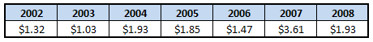

The average earnings per share is $1.88. I believe that the company will be able to achieve this level of earnings within the next two or three years when the economy improves. During the last conference call, the management mentioned that earnings are already improving. Assuming $1.88 EPS and applying a P/E ratio of 15, which is the last 5 years’ average, the company is worth approximately $28 per share.

From the dividend angle, assuming that the company will be able to keep paying $1 per share in dividends and applying a conservative dividend yield of 3%, the company is worth $33 ($1/3%) per share.

In my opinion, Ark Restaurants’ stock is worth between $28 and $33 per share. Buying it for $13 looks like a good deal to me. I am not the only one who thinks that the stock is undervalued – Gotham Asset Management and Royce & Associates, both value investors, found value in Ark Restaurants; otherwise, they wouldn’t have bought it. These two companies are discussed more in the next section.

Why is Ark Restaurants so cheap?

The price of any stock goes up or down depending on the supply and demand of buyers and sellers. These players might have different reasons to buy and sell, but their actions are always reflected in the stock prices. In the case of Ark Restaurants, the heavy selling by major owners caused the price of its stock to decline from around $35 per share at the end of 2007 to less than $10 per share at the end of 2008. According to the SEC filings, Loeb Partners Corporation, Prides, Capital Partners, and Kirkwood Capital were some of the major owners of Ark Restaurants. The table below shows their holdings.

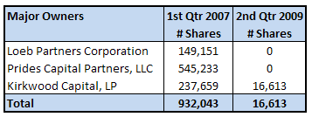

By the end of the first quarter of 2007, these owners held 932,043 shares, which is close to 30% percent of the company since there are over 3 million shares outstanding. By the end of the second quarter of 2009, they held only 16,613 shares, which meant that they sold over 900,000 shares. Again, since this constitutes almost 30% of the company, this kind of selling would collapse the price of any stock. The timing of their sales is reflected in Ark Restaurants’ stock price. The following graph illustrates this point.

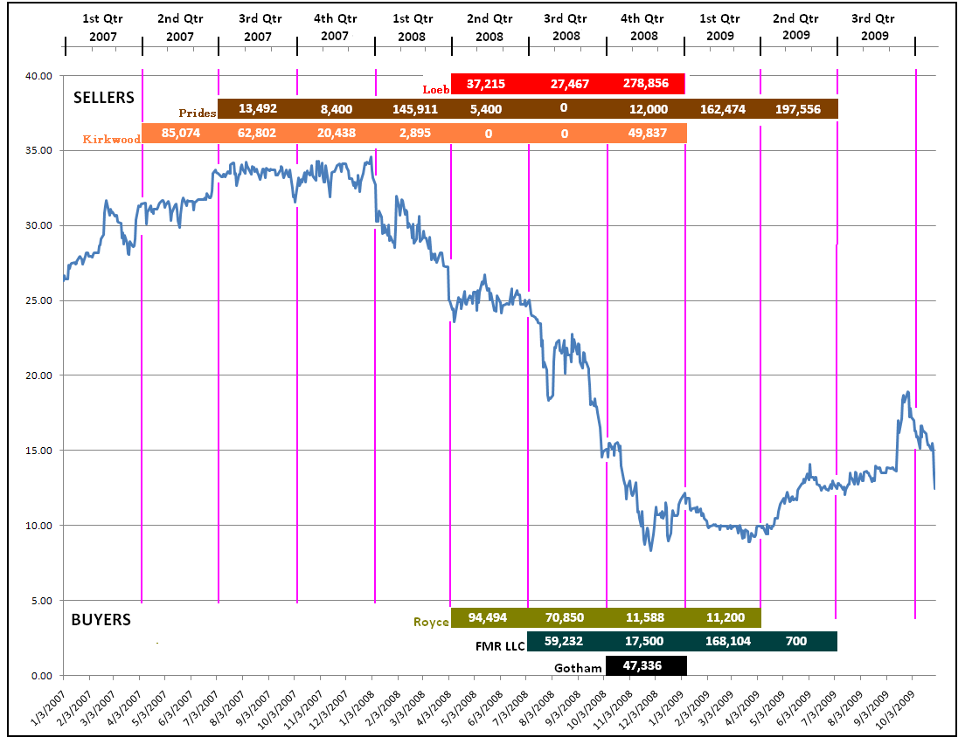

In this graph, sellers are listed on the top and buyers are listed on the bottom. First, I will focus on the sellers. During the second quarter of 2007, Kirkwood Capital sold 85,074 shares. During the third quarter, Prides Capital Partners joined Kirkwood Capital and sold 13,492 shares. The price of Ark Restaurants’ stock wasn’t really affected yet, since the number of shares sold by these owners wasn’t that significant. Ark Restaurants’ stock price started declining during the first quarter of 2008, when Prides Capital Partners liquidated 145,911 shares, which represented close to 5% of Ark Restaurants’ shares. During the second quarter of 2008, Loeb Partners Corporation joined the sellers and liquidated 37,215 shares. Because Prides Capital Partners and Kirkwood Capital did not sell that much during this quarter, and one of the buyers, Royce & Associates, bought 94,494 shares, Ark Restaurants’ stock price stabilized at around $25 per share. Even though Royce & Associates and FMR LLC bought 130,082 shares during the third quarter of 2008, compared with Loeb Partners Corporation’s selling of 27,467 shares, this was not enough to stop the price of Ark Restaurants’ stock from collapsing to $15 per share. Let’s remember that the third quarter of 2008 was the beginning of a horrible selloff in the general stock market. This is when prices of all the stocks declined significantly. During the fourth quarter of 2008, Loeb Partner Corporation must have had enough because it sold all of its remaining 278,856 shares. Prides and Kirkwood joined in. Together, they sold 340,693 or about 10% of the entire company in just one quarter during the worst stock market meltdown since the Great Depression. Amazing! No wonder the price of Ark’s stock declined below $10. Obviously, they did not think about what Ark Restaurants is worth, but simply they wanted out. During the first and second quarters of 2009, Prides Capital Partners continued their selling by liquidating a total of 360,030 shares representing another 10% of the company.

I first heard about this company in January 2009 after Gotham Asset Management purchased these shares. Joel Greenblatt, manager of Gotham, is the author of The Little Book That Beats the Market and You Can Be a Stock Market Genius. I read both of his books and I am impressed by Greenblatt’s investment abilities. I didn’t acquire Ark Restaurants’ shares then because I was looking at other stocks.

I started buying shares during the second quarter of 2009 around $13 per share. On September 16, 2009, the company announced a special dividend of $1 per share. Following this event, the stock price appreciated as high as $18 per share. In addition to the special dividend, the company reinstated its quarterly dividend in the amount of $0.25 per quarter or $1.00 per year beginning with the first quarter of the upcoming fiscal year. Purchasing one share of Ark Restaurants’ stock at $18 and getting $1 in dividends a year equates to a dividend yield of 5.5% which is incredible. Usually stocks with high dividend yields might not be that safe because when the company cuts this dividend, there may be some heavy selling. However, I don’t believe that the company will cut this dividend simply because they just reinstated it. Being familiar with Ark Restaurants’ CEO’s capital allocating decisions, I don’t believe that he would reinstate a dividend if he did not think that the company could sustain paying it.

With that being said, after purchasing Ark Restaurants’ stock at around $18 for some of you, the stock price got hammered during the last week to below $13 per share, making it a 30% paper loss. While this doesn’t make me happy, it also doesn’t make me lose any sleep because as Seth Klarman, manager of Baupost Group, said, “Without the possibility of near-term pain, there can be no long-term gain.” The collapse of Ark Restaurants’ stock price only illustrates the manic-depressive behavior of Mr. Market. At $13 per share, the dividend yield increases to 7.7% ($1/$13). I don’t think this price will stay this low for too long. In the end, where can you get 7.7% return on your money plus the potential for appreciation? On your savings account? I don’t think so. I am not the only one who thinks this way. Arthur Stainman, Ark Restaurants’ director, must be thinking along the same lines because on Friday, October 30, 2009, after a horrible decline in the Dow Industrial Average and Ark Restaurants’ stock price, he purchased 5,000 shares at $13.14 per share, which equates to $65,700. An insider putting $65,700 into one stock in one day tells me that Ark Restaurants’ stock is likely to be extremely undervalued at these levels.

I believe that the downside is limited at these levels, and the upside is obvious. The downside is limited because the three sellers, Loeb Partners Corporation, Prides Capital Partners and Kirkwood Capital are pretty much out. The remaining major shareholders are unlikely to surprise anyone with nonsense selling. Some might think that the new buyers, Royce & Associates, FMR LLC, and Gotham Asset Management might sell. I don’t believe they will because of their investment philosophies. Royce & Associates are value investors that specialize in small-cap companies. They purchase shares of companies significantly below their appraisal of current worth. They were buying at a level of $25 per share thinking that this is below their appraisal. At $13 per share, Ark Restaurants is even a better deal. FMR LLC is the Fidelity Low Price Stock Fund which invests for the long term. Their belief is that riding out the markets’ inevitable ups and downs has proven much more effective than selling into panic or chasing the hottest trend. They definitely proved this point by not selling during the panic. They also believe in broad diversification, and therefore, hold almost 900 positions in their fund. For them, Ark Restaurants’ stock represents less than 1% of the portfolio. It would not affect them even if Ark’s stock went to $0. Joel Greenblatt of Gotham Asset Management also believes that Ark Restaurants’ stock is undervalued. He does not believe in diversification. Over the last three quarters, he only held three positions in his fund. As of the last statement, he sold two and held Ark Restaurants. I don’t think he is a seller anytime soon. But even if he is, he only owns 47,336 shares which is slightly more than 1% of the company, which is not enough to move the price as significantly as the original three sellers.

Conclusion

The struggling economy with high unemployment makes people eat out less than usual. This does not translate into increasing revenues for the restaurant industry. However, being opportunistic, I believe that this is a perfect time to buy because recessions and booms don’t last forever. Because Ark Restaurants carries no debt and cash flows on all of the restaurants, I am happy to buy its shares at these levels and patiently wait for things to get better. When Wall Street realizes the true potential of Ark Restaurants, they will come back and offer us much better prices for Ark Restaurants’ stock and I will be happy to sell it to them after making good returns.

